2.3. Some apps have location tracking system which may not be useful when donor’s GPS is off. If donors GPS is off the receiver will not be able to communicate with the donor and in the case if the GPS is on there are rare conditions to find the donor as shown in Fig.2.3.1. and the GPS reduce the battery.

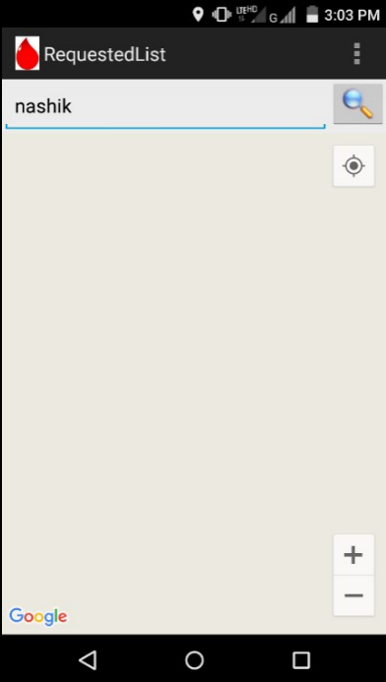

Fig.2.5: Screenshot of Donate Blood Save Life’s